Online Entry Instructions

Navigate to the online entry site:
Anne Arundel County Fairgrounds Online Entry or type in:
https://www.blueribbonfair.com/BRFairProd/BlueRibbonStart.aspx?ID=1527

Once on the Blue Ribbon Fair website, click create account. 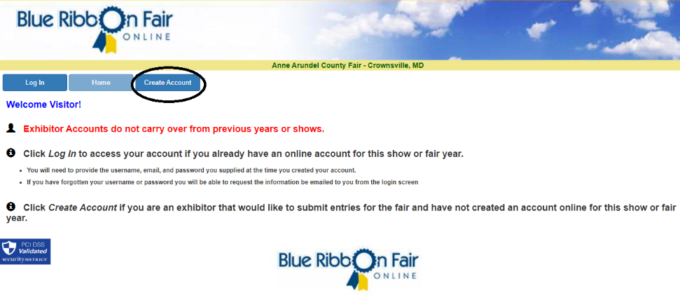

2. Enter exhibitor information
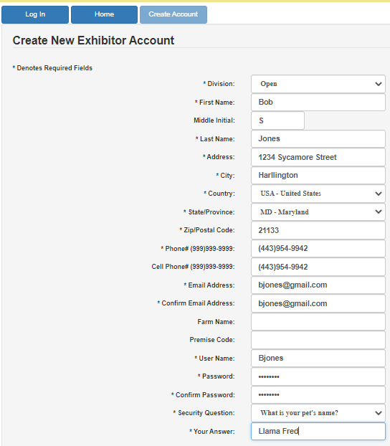

3. Once all information has been entered, click save account information
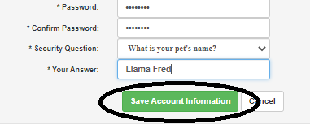

4. Accept Terms
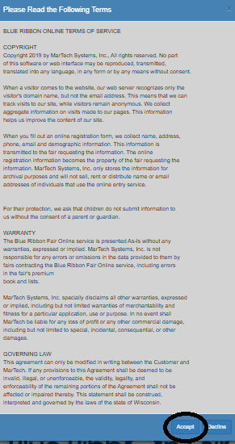

5. Once the screen displays exhibitor, click on Entries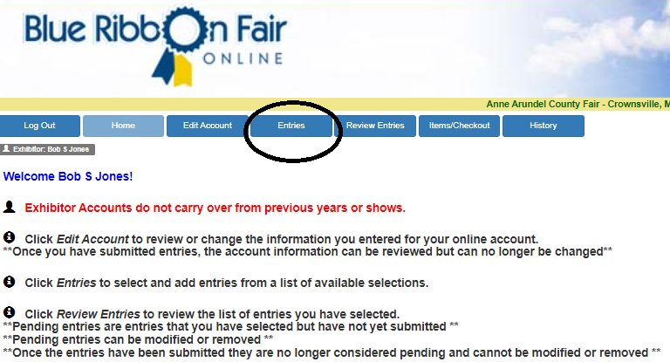.

6. The next screen will show the Departments that are open for online entries. Click on the department you would like to enter.
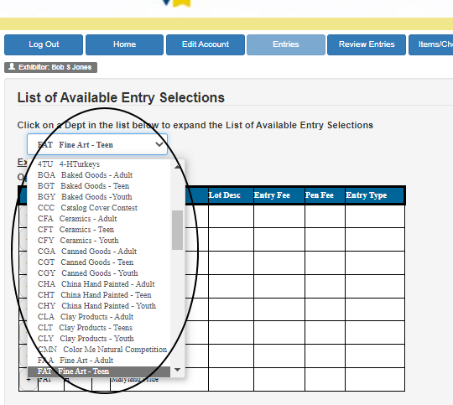

7. You will then notice another box of the available entries of Department & Division.
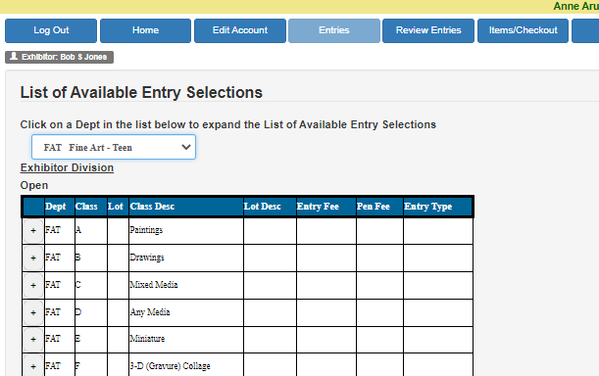

8. Click on the plus sign (+) next to the department number show all the classes listed under that department.

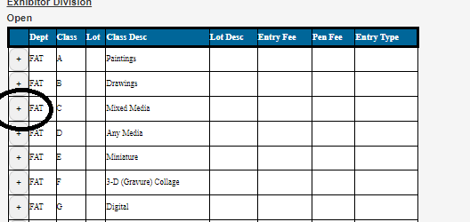

9. Once you have identified the correct class, click add.
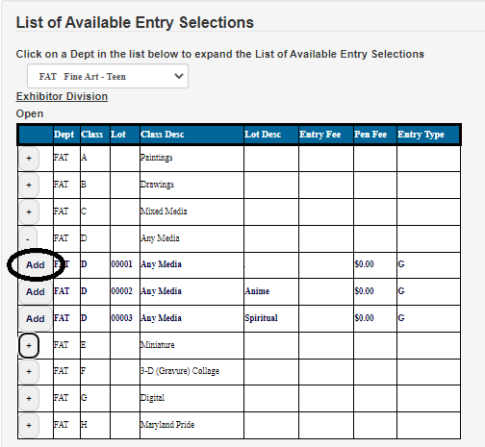

10. Repeat steps for other entries.

11. Once you have entered all your open class items, click Review Entries. This will show total entries, total entry fees, etc.
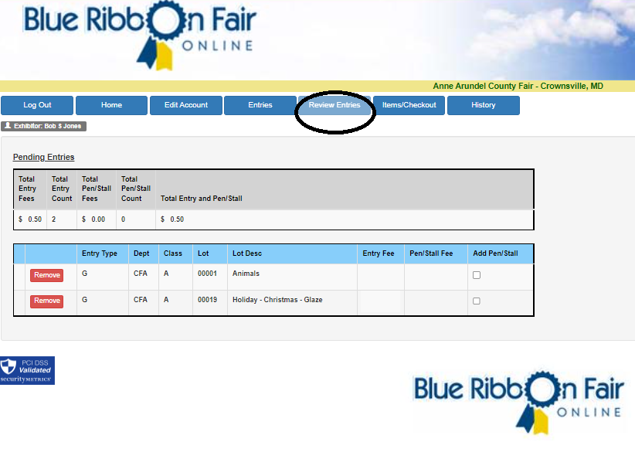

12. Once entries have been reviewed, click on submit.

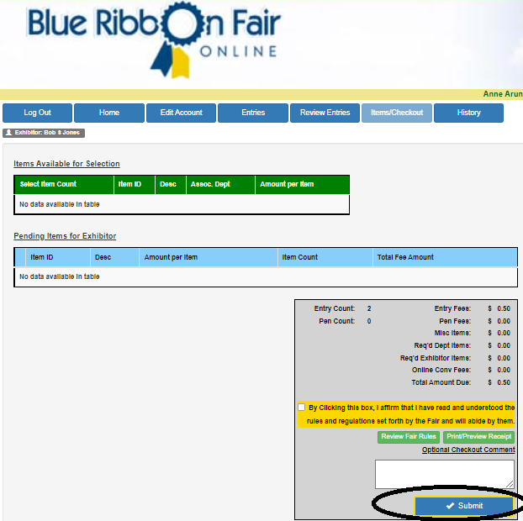

13. Once you have checked out, click on history & print.
